**YouTube tutorial 66 – Writing Custom File Structures**

https://www.youtube.com/watch?v=iGWhPwh3n-o&list=PLAE85DE8440AA6B83&index=66

#include "stdafx.h"

#include <iostream>

#include <fstream>

#include <string>

using namespace std;

int main()

{

ofstream outFile("watsup.txt");

int id;

string name;

int age;

cout << "Enter information in following order: 'ID' 'Name' 'Age'" << endl;

cout << "Press CTRL+Z to exit..." << endl;

while (cin >> id >> name >> age) {

outFile << id << " " << name << " " << age << endl;

cout << "The following line is entered: ";

cout << id << " " << name << " " << age<<endl;

}

return 0;

}

**Result:**

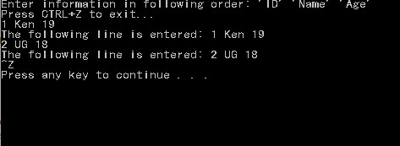

**File created:**



**Important notes:**

* CTRL+Z implies the end-of-the-file. By doing this, you can stop the program anytime
* That means, when CTRL+Z is written in the input, the loop will become **while(end-of-the-file=true)** 🡨Used informal language there
* When you enter more than 3 things, only the first 3 will be taken to our variables